NAME: ASJID TAHIR  
CLASS: BSCS  
ROLL NO: 19p0085

COURSE: DLD LAB

SECTION: 2B2

QUESTION # 01:

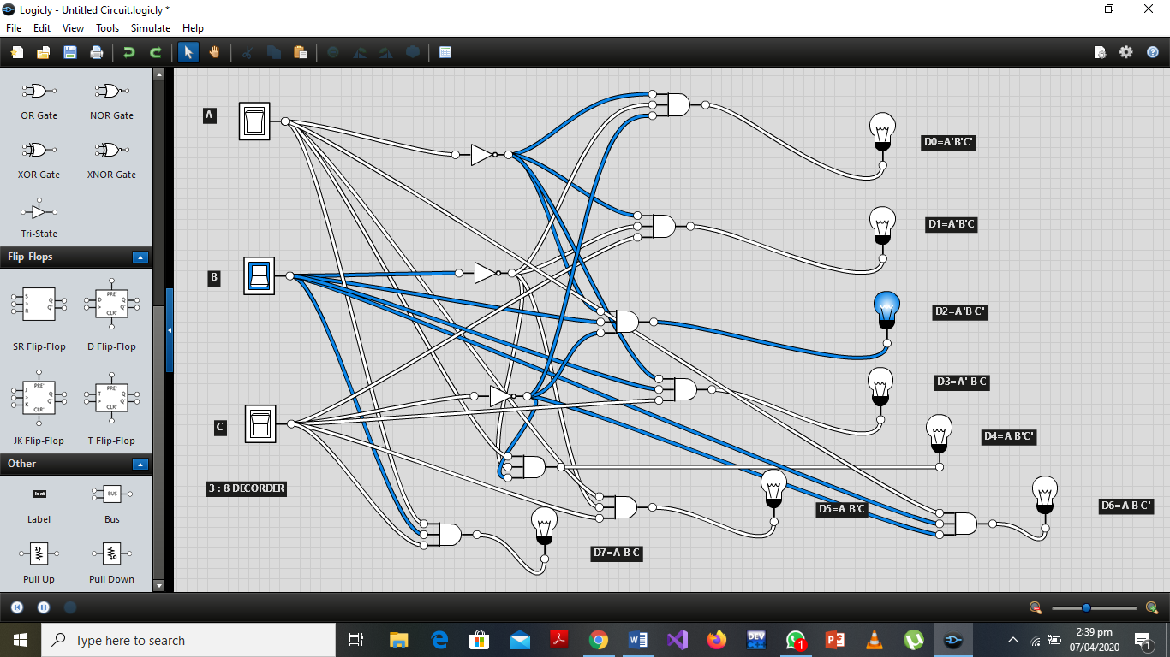3:8 Decoder: